A. Preparing the repository with initial data on GitLab

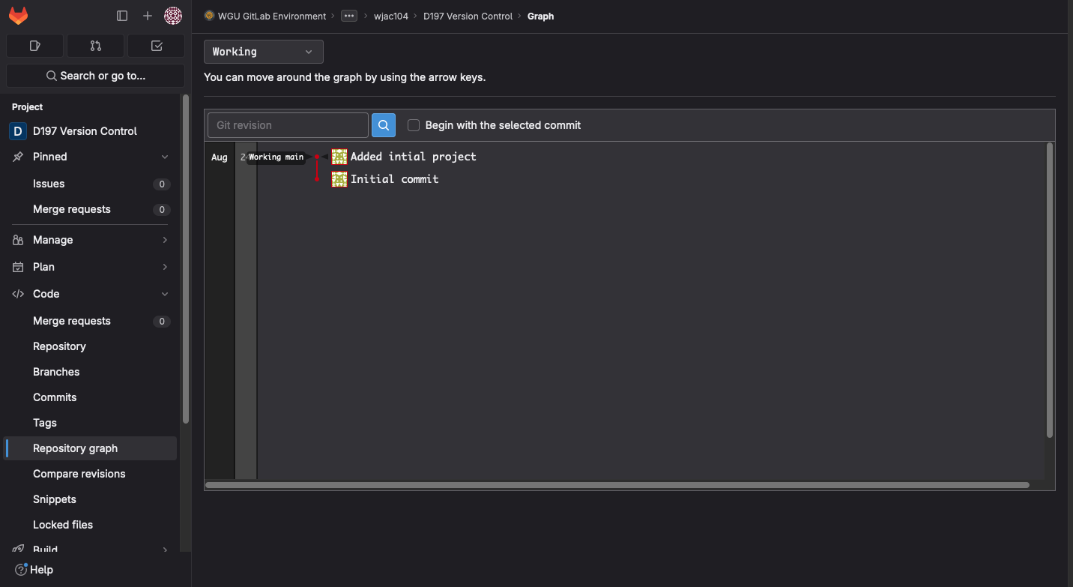
B. Cloning the repository to my local machine

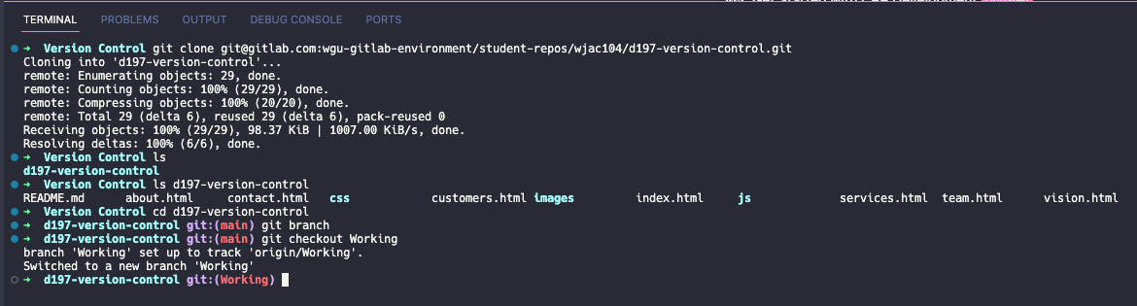
C. Making changes, committing, and pushing

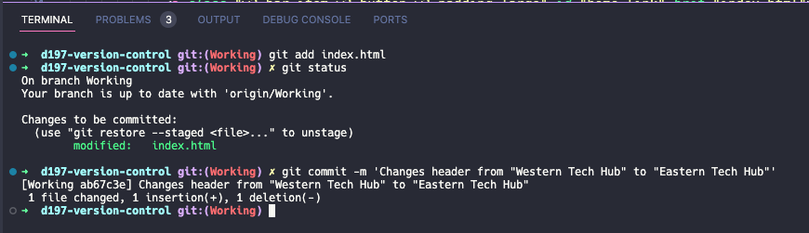
C.1 Committing three changes

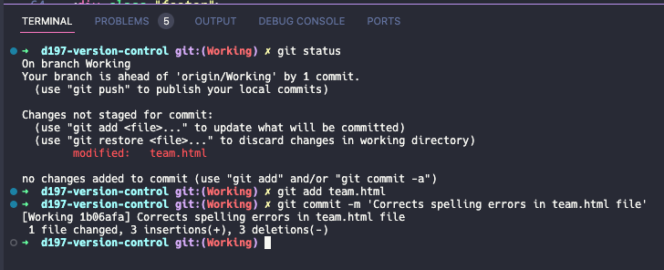
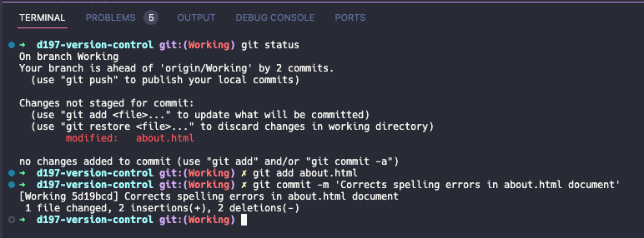
C.2 Pushing branch to Gitlab

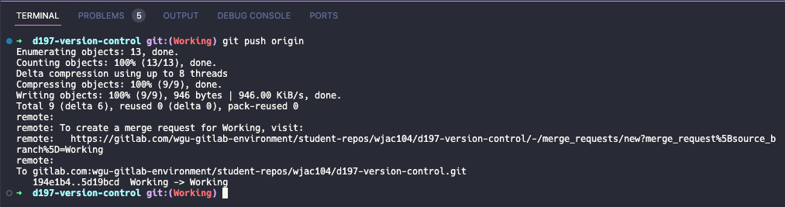

D. Creating a new branch and making a change

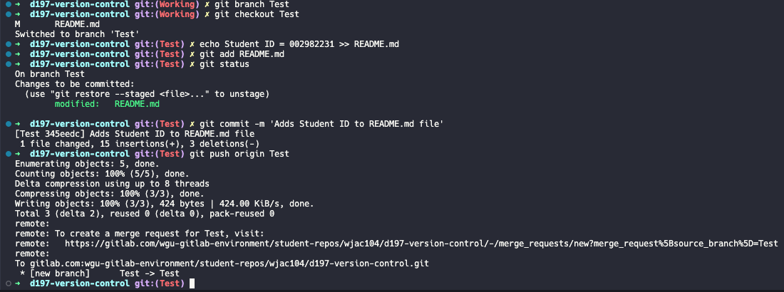
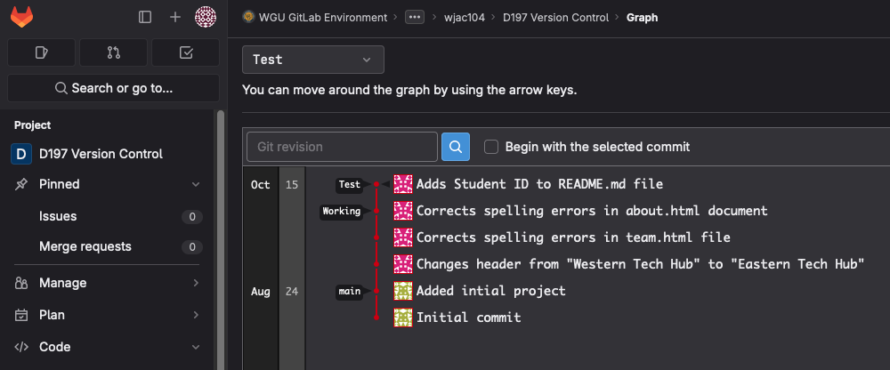
E. Simulating a merge conflict

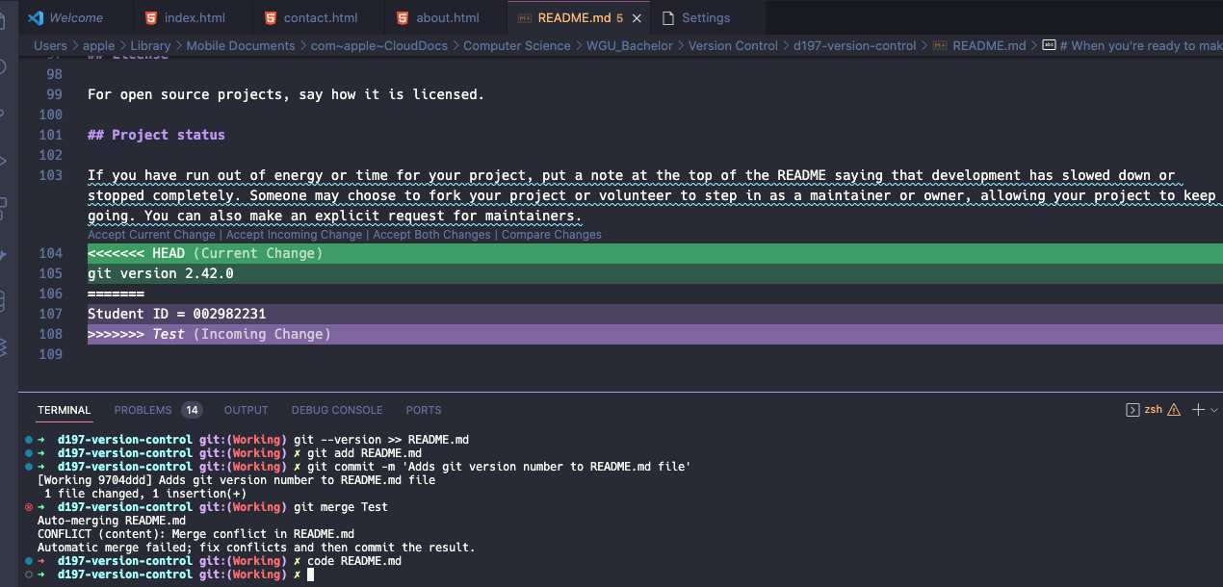

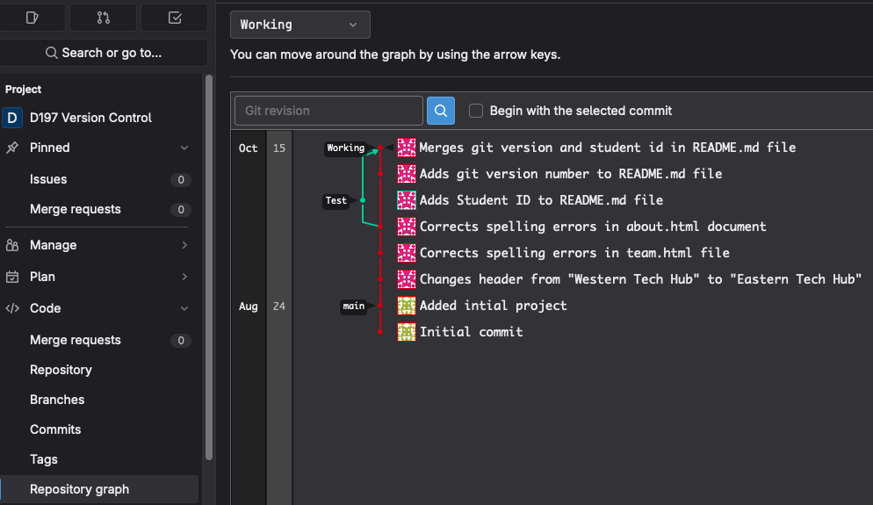
E.1 Resolving the conflict and pushing the changes

F. Tagging the Working branch

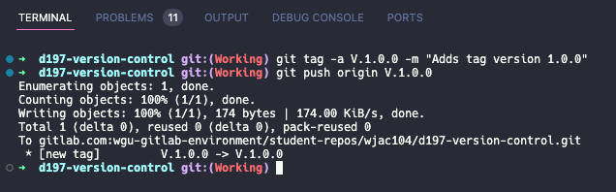

F.1. Repository graph of the Working branch in GitLab
